FINAL REPORT:

SMART FIRE SYSTEM

🕮

17DTHQA2

Nhóm 10:

Trần Anh Quân (1711062365)

Nguyễn Ngọc Đức (1711060093)

Phùng Tuyền Hào (1711061809)

**1. Introduction 3**

a. Overview 3

b. Purpose 3

c. Product Scope 4

**2. Design 4**

a. Scrum Board 4

b. UML class design 5

c. Database design 6

d. GUI (Graphical User Interface) 7

**3. Overall Description 9**

a. Function system requirement 9

b. System's behavior 11

c. Features 14

**I. Introduction**

a. Overview :

- Fire Alarm System is designed to alert us to an emergency so that we can take action to protect ourselves, staff and the general public.

- Fire alarms are found in Offices, Factories, and public buildings, they are a part of our everyday routine but are often overlooked until there is an emergency at which point, they might just save our lives.

- Right now, we start to expand the range of alarm by designing a "Smart" Fire system which we can alarm users through the user's smartphone.

b. Purpose

- Early detection and warning of a fire.

- Provide surveillance solutions, follow the situation well and rescue the victim quickly.

- Minimize damage to people and property.

- Provide a compability to multiple types of fire detector.

c. Product scope

- The best-recommended practice is aimed at specifying the requirements of the software to be developed but also can be applied to assist in the selection of in-house and commercial software products.

- When SFS is embedded in some larger system, such as school, hospital, hotel, etc... Then issues beyond those identified in this recommended practice may have to be carefully addressed and customized.

**II. Design**

a. Scrum board

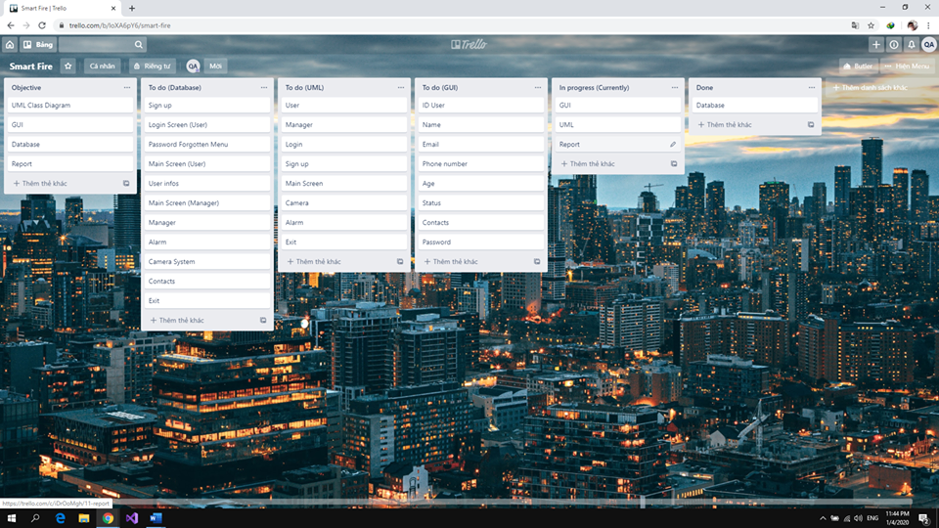

b. UML class design

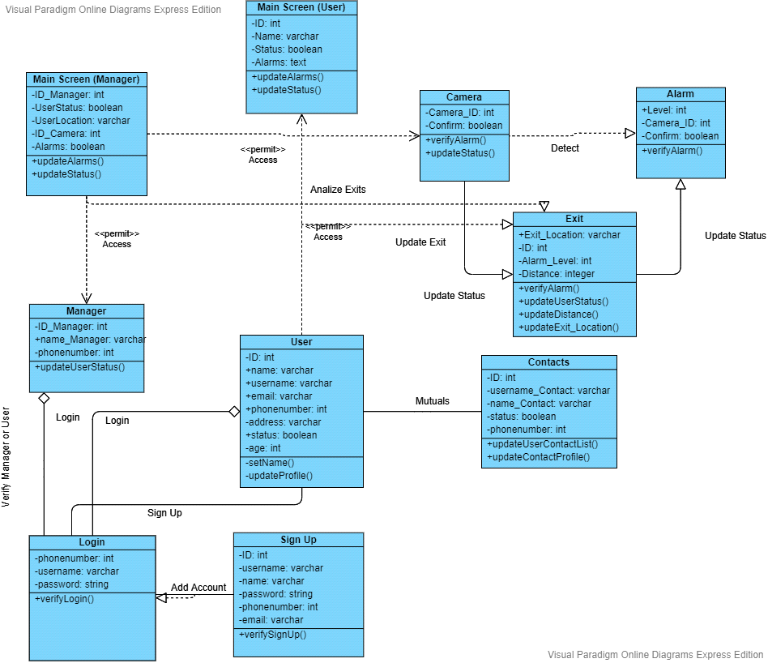

c. Database design

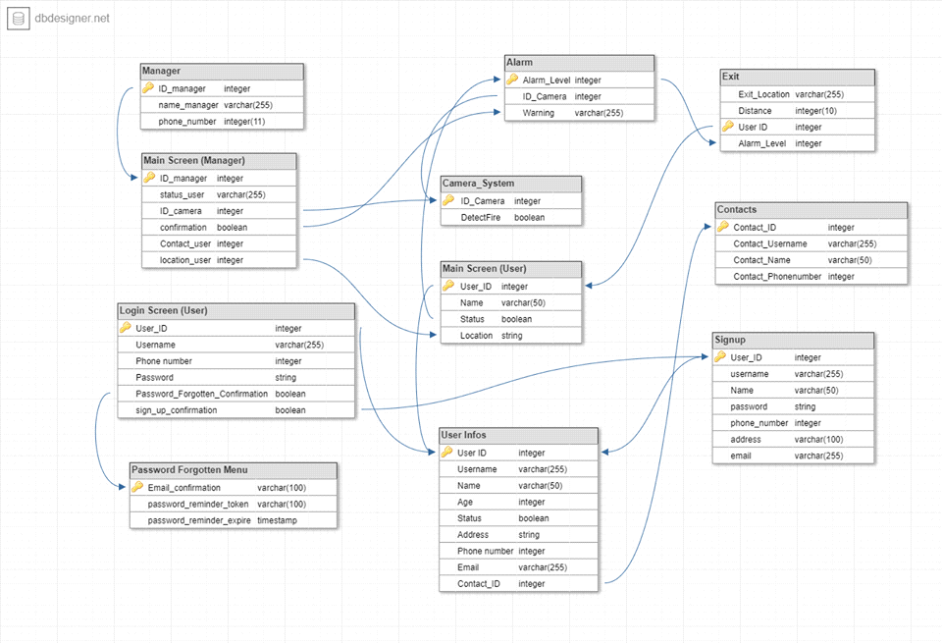

d. GUI

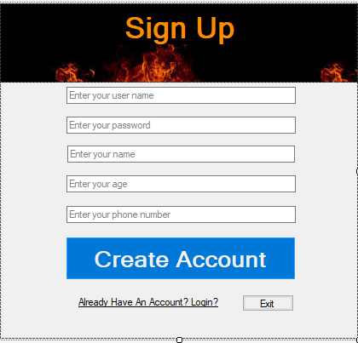

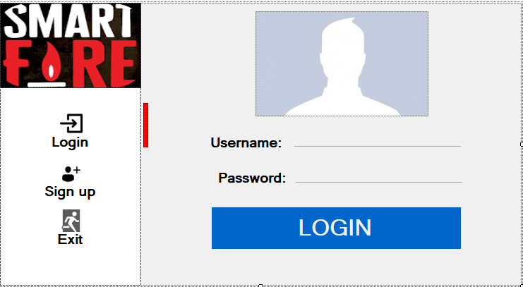

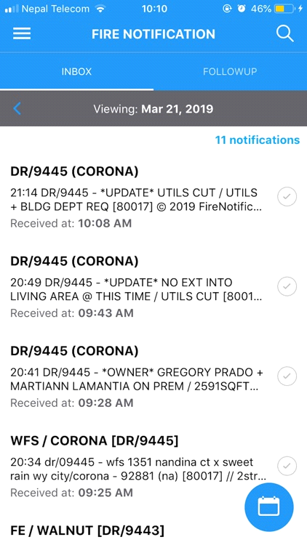

**III. Overall Description**

a. Function system requirement:

+ Manager:

- Setting up sensors (depending what type of sensors) and surveillance cameras optimized due to the minimum of total number requirement of the SF system is 50 each's.

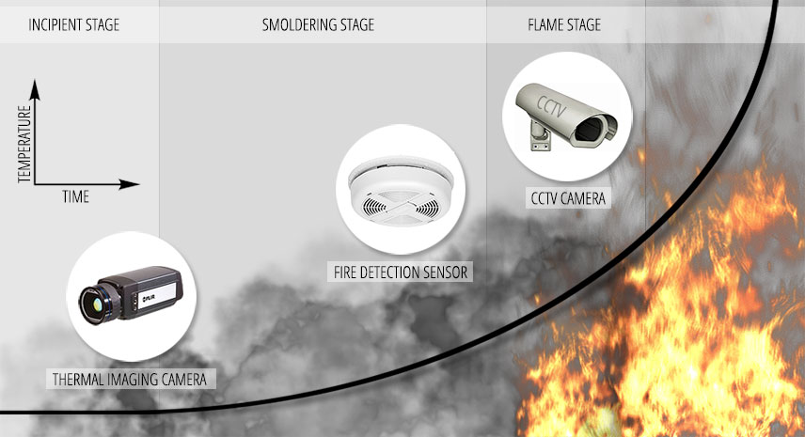

- A server room that contains AI service, Alarm server, and Streaming server and is highly recommended to prohibit the numbers of bypassers beside the manager and staff.

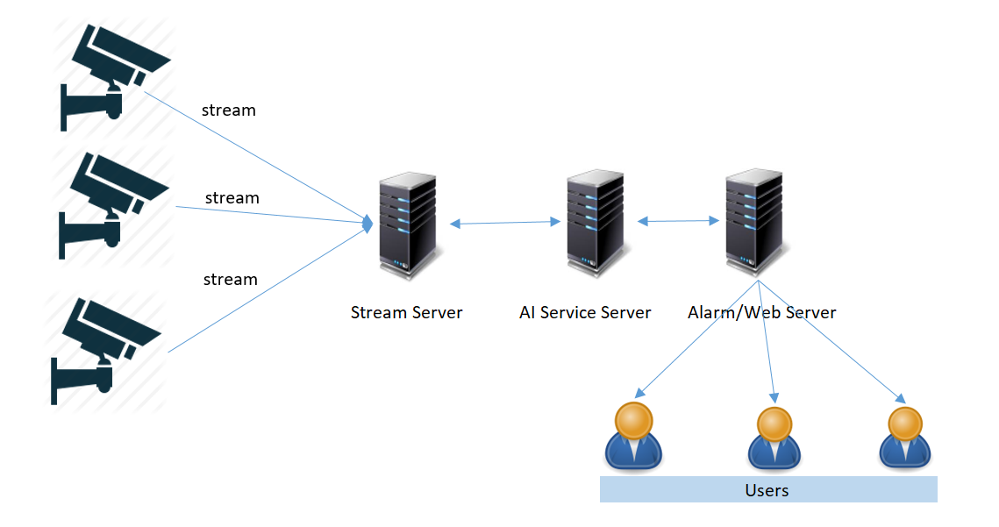

- A power supply generator is also highly recommended in case of power outage deployment.

+ User:

- User need to download the app which will be available in IOS/Android.

- Users's login is an essential part for the app to function, and users's device must be online.

- Additionally, users must accept SFS's permission to allow the app itself to fully function.

b. System's behavior:

We will provide a unique feature for separate role between manager and users:

- The manager will have a full control of SF system as an admininstator. The system will immediately notify the manager to confirm when the system detects fire, smoke, explosion or a potential fire event in an incoming time. They are immediately provided with the most optimized solution and wait for the manager's confirmation. After the confirmation, the system will notify all users around and inside range of fire. In the case of the manager's absence, the AI service will taking place and self-confirming the situation.

One of the surveillance cameras has found the fire:

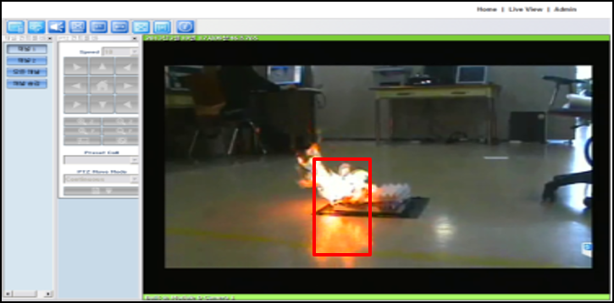

During the manager's absence:

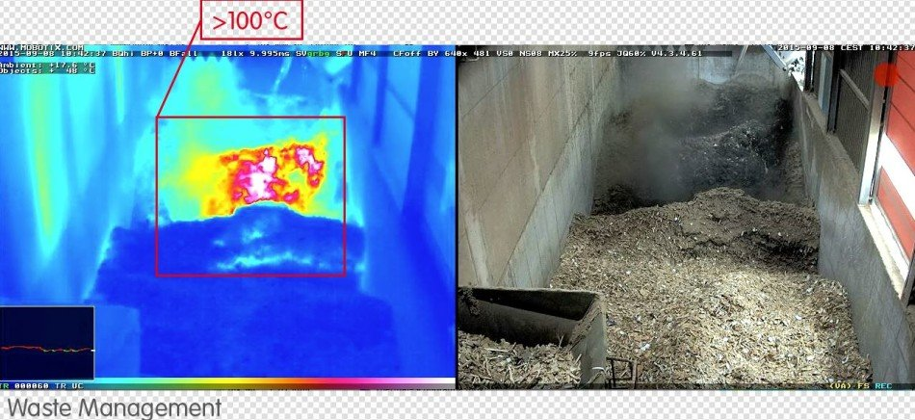

- Users in or near the fire area will be immediately notified to confirm the user's status. When the situation is confirmed successfully, the system will give priority to users in danger to collect information and optimize the safest exit and then warn those near that range. Also, 114 will be immidiately called at the same time.

For users in SOS status:

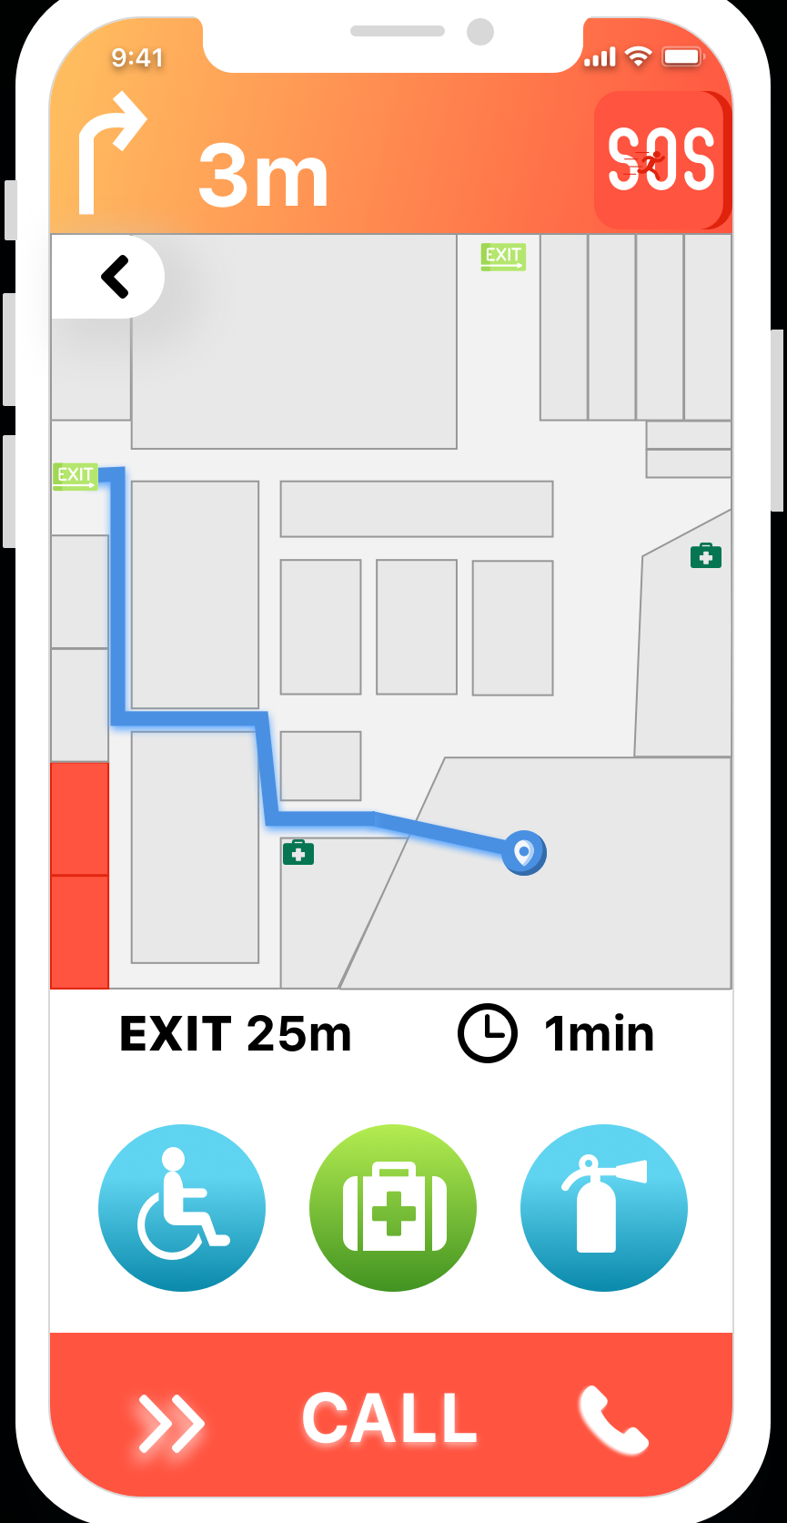

For those in safe status: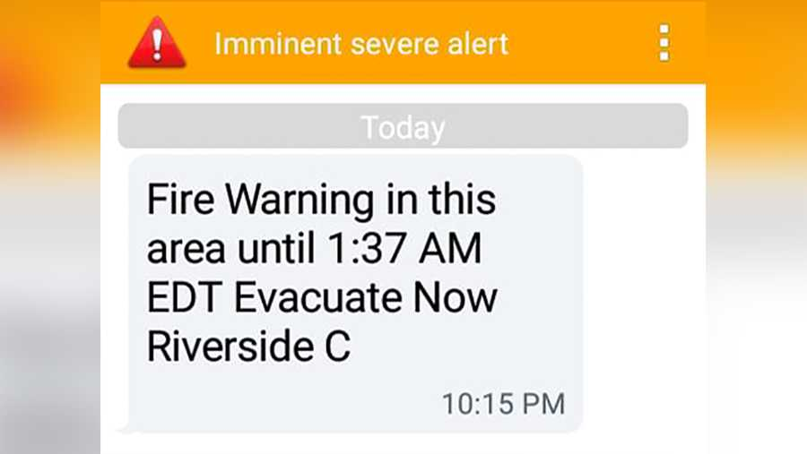

c. Features

- Providing detection more accurately and giving ample time for families to evacuate before the fire spreads and takes over the entire building or property.

- Moreover, it informs the authorities to send help to take control of the situation which is a must-have solution for residents living villas, apartments or commercial buildings.

- SFS ensures to build a Smart firewall for homes reducing injuries, property damage, or any other financial loss.

- Smart Fire alarm system offers exceptionally secure communications while providing the flexibility and ease of wireless installation.

- These devices feature anti-tamper protection and exceptionally long-range that work reliably without the need for repeaters.

- The system will be always provided with incoming updates and new features to reduce the numbers of unforeseen bugs and sudden crashes through testing and customer feedbacks.

-THANKS FOR READING-